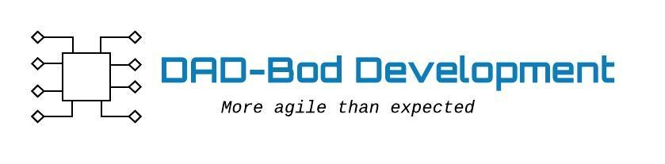

**Initial Modeling - whiteboarding, mind-mapping, use cases, UML diagrams**

